A228-Afr-Egy-Amulet-New Kingdom-18th Dynasty-1549-1292 BCE-Double Crown-Blue Faience

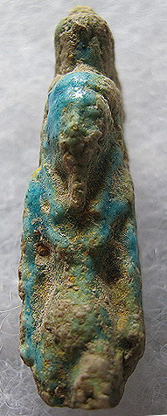 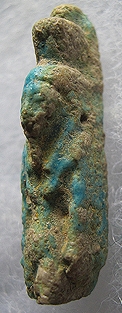 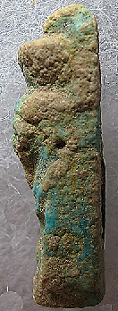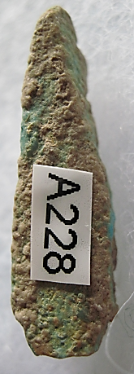

Figs. 1-4. Amulet-New Kingdom-18th Dynasty-1479-1458 BCE-Hatshepsut-Blue Faience

**Case No.: 2.**

**Formal Label:** Amulet-New Kingdom-18th Dynasty-1479-1458 BCE-Hatshepsut-Blue Faience

**Display Description:** This blue faience Amulet is a female who wearsthe false beard of kings andthe double crown or *sekhemti*, known as the “Two Powerful Ones:” the red crown (Deshret) of Lower Egypt and the white crown (Hedjet) of Upper Egypt. The only possible female pharaohs whom this amulet could be are Sobekneferu, who reigned 1806 to 1802 BCE and Hatshepsut (1507–1458 BCE), who reigned 1480-1458 BCE. Sobekneferu was ill when she came to the throne and only reigned four years. On the other hand, Hatshepsut came to the throne in 1479 BCE and ruled solely for twenty-one years, nine months, as the pharaoh, since the regent, Thutmose III (her son) was a two-year-old child when she ascended the throne.

This small Ushabti which was used as an amulet honoring this foremost woman pharaoh was probably the property of a female commoner who took great pride in her pharaoh. Indeed, Hatshepsut, the chief wife of Thutmose II, was to reign longer than any other indigenous Egyptian (Tyldesley 1996).

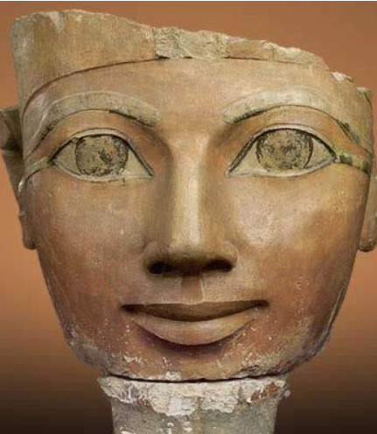 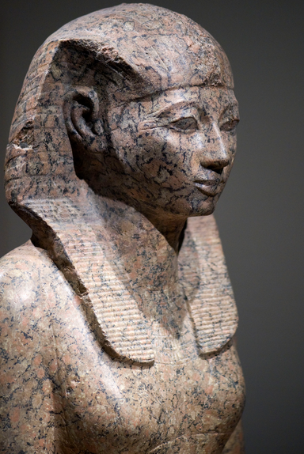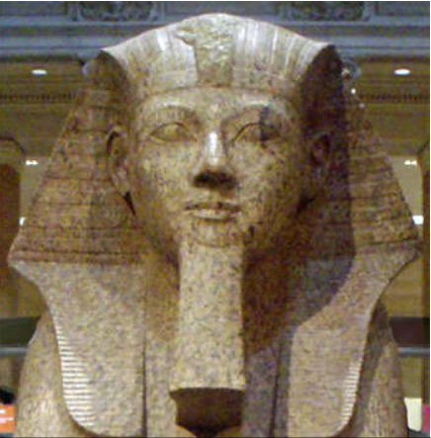 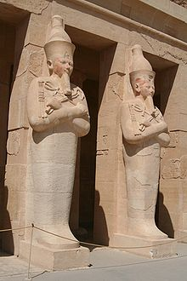 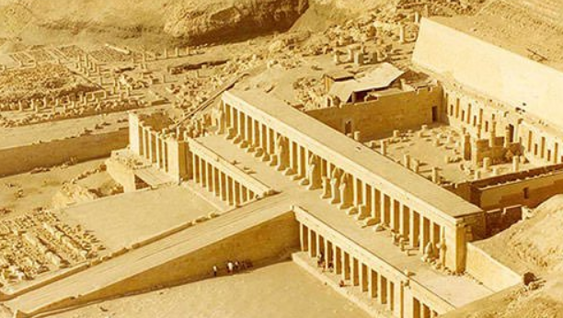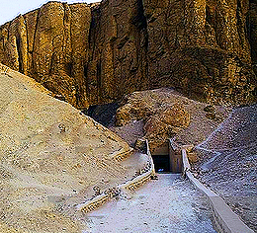

Fig. 5. Head of a statue of Hatshepsut, painted limestone, Deir el-Bahri, Funerary Temple of Hatshepsut, Metropolitan Museum of Art Excavations of 1926 from http://www.touregypt.net/images/touregypt/headhatshepsut.jpg

Fig. 6. Statue of Hatshepsut from https://upload.wikimedia.org/wikipedia/commons/2/25/WLANL_-_koopmanrob_-_Maat-ka-Re_Hatsjepsoet_%28RMO_Leiden%29.jpg

Fig. 7. Granite sphinx bearing the likeness of Hatshepsut with a false beard, a symbol of her pharaonic power Metropolitan Museum of Artfrom <https://learnodo-newtonic.com/wp-content/uploads/2014/09/Hatshepsut-Facts-Featured-Image-932x352.jpg>

Fig. 8. Osirian statues of Hatshepsut at her tomb, one stood at each pillar of the extensive structure, note the mummification shroud enclosing the lower body and legs as well as the crook and flail associated with Osiris at Deir el-Bahri*.* ***These statues may have served as the models for the amulet of Hatshepsut.***

Fig. 9. The mortuary Temple of Hatshepsut, the Djeser-Djeseru (“Holy of Holies”), is located beneath the cliffs at Deir el Bahari, on the west bank of the Nile near the Valley of the Kings. from <https://learnodo-newtonic.com/wp-content/uploads/2014/09/Mortuary-Temple-of-Hatshepsut.jpg>

Fig. 10. Tomb KV20 of Hatshepsut and her father, Valley of the Kings.

**Accession Number: A228**

**LC Classification:** DT62

**Date or Time Horizon:** 1480-1458 BCE

**Geographical Area: Deir el-Bahari**

**Map, GPS Coordinates:** [25°44′18″N 32°36′28″E](https://tools.wmflabs.org/geohack/geohack.php?pagename=Deir_el-Bahari&params=25.738333333333_N_32.607777777778_E_)

**Cultural Affiliation:** New Kingdom

**Medium:** Blue Faience

**Dimensions: H 36.51 mm, 1.437 in.  
Weight: 1 gm; 0.035274 oz.**

**Provenance: Old European collection**

**Condition: Original**

**Discussion:**

Under Hatshepsut, a united monarchy was a prominent factor of pride as she was eminent in her administration of the two regions, Upper and Lower Egypt, that had suffered under the Hyksos and the disruption of trade with the Levant. In fact, Hatshepsut was known as the “Foremost of Noble Ladies” and as the fifth pharaoh of the Eighteenth Dynasty, she was honored by everyone. She also took pride in wearing the false regnal beard of pharaohs, and, in fact, was acknowledged as king, and not queen, of Egypt by Year 7 of her reign (Tyldesley 1996: 99).

Hatshepsut suffered from a bone cancer, probably multiple myeloma, and because she was bothered by squamous carcinomas that can result from complications of this malady, she used a skin salve that contributed to this additional affliction because the salve contained carcinogenic compounds. A calcite unguent jar with her own cartouche on it may have been the container that held the carcinogenic salve.



Fig. 5. A cosmetic vial found among Hatshepsut’s possessions at Deir el-Bahari. The vessel was thought to have held perfume until a two-year study uncovered traces of what appears to be an ancient treatment for eczema or psoriasis. Its ingredients included palm and nutmeg oil, fatty acids that can relieve certain skin conditions and a type of cancer-causing tar residue. The University of Bonn, Egyptian Museum. From http://cdn.history.com/sites/2/2015/05/hith-skin-cream-kill-hatshetpsut-E.jpeg

When she died at age 65 which is within the date range for death by this disease if left untreated, she was interred in the tomb of her father, KV20 (Tyldesley 1996: 207). However, when Thutmose III came on the throne a deliberate plan of defacement of all of Hatshepsut’s visible monuments indicating her accomplishments was initiated and any memory of her reign was expunged from the public record. This small amulet was probably among the last of those amulets that were fabricated before the plan of defacement was undertaken and the proscription of her amulets was enforced.

**References:**

Jennie Cohen, ["Did Skin Cream Kill Egypt’s Queen Hatshepsut?"](http://www.history.com/news/did-skin-cream-kill-egypts-queen-hatshepsut), *History*, August 19, 2011.

Gabolde, Luc (1987), *La Chronologie du règne de Tuthmosis II, ses conséquences sur la datation des momies royales et leurs répercutions sur l'histoire du développement de la Vallée des Rois*, SAK 14: pp. 61–87.

Tyldesley, Joyce. 1996. Hatchepsut: The Female Pharaoh. London: Penguin Books